Experiment 6

Sequence Diagram

Software engineering

Introduction

# A sequence diagram simply depicts interaction between objects in a sequential order i.e. the order in which these interactions take place. We can also use the terms event diagrams or event scenarios to refer to a sequence diagram. Sequence diagrams describe how and in what order the objects in a system function. These diagrams are widely used by businessmen and software developers to document and understand requirements for new and existing systems. Basic Use Case Diagram Symbols and Notations

1. Actors

An actor in a UML diagram represents a type of role where it interacts with the system and its objects. It is important to note here that an actor is always outside the scope of the system we aim to model using the UML diagram.

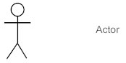

We use actors to depict various roles including human users and other external subjects. We represent an actor in a UML diagram using a stick person notation. We can have multiple actors in a sequence diagram.

1. Lifelines

A lifeline is a named element which depicts an individual participant in a sequence diagram. So basically, each instance in a sequence diagram is represented by a lifeline. Lifeline elements are located at the top in a sequence diagram. The standard in UML for naming a lifeline follows the following format – Instance Name: Class Name

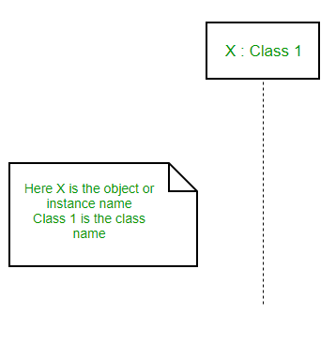

We display a lifeline in a rectangle called head with its name and type. The head is located on top of a vertical dashed line (referred to as the stem) as shown above. If we want to model an unnamed instance, we follow the same pattern except now the portion of lifeline’s name is left blank.

SEQUENCE DIAGRAM

----------------------------------------IMAGE HERE--------------------------------------